**SMART AMBULANCE SERVICE**

## A PROJECT REPORT

***Submitted by,***

**Mr. MAHESH -20201CSE0710**

**Mr. AKSHAY M -20201CSE0681**

**Mr. PRASHANT S H -20201CSE0689**

**Mr. H DILEEP -20201CSE0677**

### *Under the guidance of,*

**Mr. Prakash B Metre**

***in partial fulfillment for the award of the degree of***

**BACHELOR OF TECHNOLOGY**

**IN**

**COMPUTER SCIENCE & ENGINEERING.**



**PRESIDENCY UNIVERSITY**

**BENGALURU**

**JANUARY 2024**

**PRESIDENCY UNIVERSITY**

**SCHOOL OF COMPUTER SCIENCE & ENGINEERING**

**CERTIFICATE**

This is to certify that the Project report **“SMART AMBULANCE SERVICE”** being submitted by MAHESH, AKSHAY M, PRASHANT S H, H DILEEP bearing roll numbers 20201CSE0710, 20201CSE0681, 20201CSE0689, 20201CSE0677 in partial fulfilment of requirement for the award of degree of Bachelor of Technology in Computer Science and Engineering is a Bonafide work carried out under my supervision.

|  |  |
| --- | --- |
| **Mr. Prakash B Metre**  Assistant Professor  School of CSE & IS  Presidency University | **Dr. Pallavi R**  Associate Professor & HoD  School of CSE  Presidency University |

|  |  |  |
| --- | --- | --- |
| **Dr. C. KALAIARASAN**  Associate Dean  School of CSE & IS  Presidency University | **Dr. L. SHAKKEERA**  Associate Dean  School of CSE & IS  Presidency University | **Dr. MD. SAMEERUDDIN KHAN** Dean  School of CSE & IS  Presidency University |

**PRESIDENCY UNIVERSITY**

**SCHOOL OF COMPUTER SCIENCE & ENGINEERING**

**DECLARATION**

We hereby declare that the work, which is being presented in the project report entitled **SMART AMBULANCE SERVICE** in partial fulfilment for the award of Degree of **Bachelor of Technology** in **Computer Science and Engineering**, is a record of our own investigations carried under the guidance of **Mr. Prakash B Metre, Assistant Professor,** **School of Computer Science and Engineering, Presidency University, Bengaluru.**

We have not submitted the matter presented in this report anywhere for the award of any other Degree.

|  |  |  |
| --- | --- | --- |
| **NAME** | **ROLL NO** | **SIGNATURE** |
| MAHESH | 20201CSE0710 |  |
| AKSHAY M | 20201CSE0681 |  |
| PRASHANTH.S.H | 20201CSE0689 |  |
| H DILEEP | 20201CSE0677 |  |

|  |  |
| --- | --- |
|  |  |

**ABSTRACT**

India's emergency medical response faces challenges due to a lack of technological integration at the grassroots level. To address this, we propose implementing a smart ambulance system that could significantly enhance India's emergency services on a global scale.

Recent advancements in the Internet of Things (IoT) have revolutionized data processing, offering seamless integration across various systems. By harnessing IoT and smartphone technologies, our aim is to develop an inclusive platform accessible to all smartphone users.

The proposed application utilizes GPS hardware to track ambulance locations and utilizes the Google Maps API to showcase real-time ambulance details on the Smartphone App's Google Map Client. Additionally, users can locate hospitals and access brief information about their services through another module in the app.

In tandem with advanced ambulances equipped with medical facilities, patient health details can be transmitted to hospitals for immediate action. The interaction between smartphones and a centralized database will be facilitated through Representational State Transfer Application Programming Interfaces (REST APIs). The adaptable nature of these platforms allows for seamless integration of various services, potentially revolutionizing public healthcare services.

This initiative aims to bridge the technological gap in India's emergency medical response and could serve as a transformative step in improving the country's healthcare system.

**ACKNOWLEDGEMENT**

First of all, we indebted to the **GOD ALMIGHTY** for giving me an opportunity to excel in our efforts to complete this project on time.

We express our sincere thanks to our respected dean **Dr. Md. Sameeruddin Khan**, Dean, School of Computer Science Engineering & Information Science, Presidency University for getting us permission to undergo the project.

We record our heartfelt gratitude to our beloved Associate Deans **Dr. Kalaiarasan C and Dr. Shakkeera L,** School of Computer Science Engineering & Information Science, Presidency University and **Dr. Pallavi R,** Head of the Department, School of Computer Science and Engineering, Presidency University for rendering timely help for the successful completion of this project.

We are greatly indebted to our guide **Mr. Prakash B Metre,** Assistant Professor, School of Computer Science and Engineering, Presidency University for his inspirational guidance, and valuable suggestions and for providing us a chance to express our technical capabilities in every respect for the completion of the project work.

We would like to convey our gratitude and heartfelt thanks to the University Project-II Coordinators **Dr. Sanjeev P Kaulgud, Dr. Mrutyunjaya MS** and also the department Project Coordinators **Mr. Zia Ur Rahman**, **Mr. Peniel John Whistely.**

We thank our family and friends for the strong support and inspiration they have provided us in bringing out this project.

**Mahesh**

**Akshay M**

**Prashant S H**

**H Dileep**

**LIST OF FIGURES**

|  |  |  |  |
| --- | --- | --- | --- |
| **Sl. No.** | **Figure Name** | **Caption** | **Page No.** |
| 1 | Figure 8.1 | Home Page | 26 |
| 2 | Figure 8.2 | Start Page | 27 |
| 3 | Figure 8.3 | Admin Login | 28 |
| 4 | Figure 8.4 | User Login | 29 |
| 5 | Figure 8.5 | New User | 30 |
| 6 | Figure 8.6 | Admin Main Page | 31 |
| 7 | Figure 8.7 | Register New Driver | 32 |
| 8 | Figure 8.8 | Search Ambulances | 34 |
| 9 | Figure 8.9 | Accepted Ambulances | 35 |
| 10 | Figure 8.10 | Driver Main Page | 36 |
| 11 | Figure 8.11 | Admin View Ambulances | 37 |
| 12 | Figure 8.12 | Admin View Drivers | 38 |
| 13 | Figure 8.13 | Register New Ambulance | 39 |
| 14 | Figure 8.14 | View Drivers | 40 |
| 15 | Figure 8.15 | Rejected Ambulances | 43 |
| 16 | Figure 8.16 | Register New User | 44 |
| 17 | Figure 8.17 | Firebase Project | 45 |
| 18 | Figure 8.18 | Firebase Database | 46 |

**TABLE OF CONTENTS**

|  |  |  |
| --- | --- | --- |
| **CHAPTER NO.** | **TITLE** | **PAGE NO.** |
|  | **ABSTRACT ACKNOWLEDGMENT**  **…** | **i**  **ii**  **…** |
| **1.** | **INTRODUCTION** | **1** |
| **2.** | **LITERATURE REVIEW** | **2** |
| **3.** | **RESEARCH GAPS AND EXISTING METHODS** | **4** |
| **4.** | **PROPOSED METHODOLOGY** | **6** |
| **5.** | **OBJECTIVES** | **8** |
| **6.** | **SYSTEM DESIGN AND IMPLEMENTATION** | **11** |
| **7.** | **TIMELINE FOR EXECUTION OF PROJECT (GANTT CHART)** | **14** |
| **8.** | **OUTCOMES** | **15** |
| **9.** | **RESULT AND DISCUSSIONS** | **17** |
| **10.** | **CONCLUSION** | **19** |
|  | **REFERENCES** | **20** |
|  | **APPENDIX-A PSUEDOCODE** | **22** |
|  | **APPENDIX-B SCREENSHOTS** | **26** |
|  | **APPENDIX-C ENCLOSURE** | **57** |

**CHAPTER-1**

**INTRODUCTION**

* 1. **Enhancing Emergency Response**

Discuss the integration of advanced technology, such as AI-assisted diagnostics, GPS tracking, and real-time communication systems, to improve ambulance services. Emphasize the role of AI in quick decision-making for paramedics and remote guidance from specialists.

Integrating advanced technology like AI-assisted diagnostics, GPS tracking, and real-time communication systems into ambulance services has the potential to significantly enhance emergency response and patient care.

AI can aid paramedics by providing real-time analysis of patient data gathered at the scene. This could involve interpreting vital signs, symptoms, or even images from portable devices like ultrasound or ECG machines. AI algorithms can swiftly process this information, offering diagnostic suggestions or flagging critical issues, aiding paramedics in making faster and more accurate decisions.

GPS can optimize ambulance routes, ensuring the quickest and most efficient path to the patient or the nearest appropriate healthcare facility. Moreover, it helps in real-time tracking of ambulance locations, enabling dispatchers to allocate resources effectively and update estimated arrival times for the concerned parties.

* 1. **Efficiency in Patient Care**

Explore how smart ambulances streamline patient care through optimized routes, pre-hospital treatment protocols, and connectivity with healthcare facilities for seamless patient handovers.

Smart ambulances are transforming patient care by leveraging technology to enhance various aspects of emergency medical services

Advanced technology in ambulances supports paramedics with on-board AI-assisted diagnostic tools and access to medical records. This facilitates better decision-making regarding immediate treatment, medication administration, or even preliminary diagnostics, optimizing care before arrival at a healthcare facility.

Smart ambulances are equipped with communication systems that establish real-time connections with hospitals or healthcare facilities. This connectivity allows paramedics to transmit vital patient data

**1.3 Data-Driven Operations**

Highlight the significance of data analytics in predicting demand, resource allocation, and proactive maintenance of ambulance fleets, ensuring readiness during peak hours or emergencies.

Provide detailed information under each subtopic, discussing specific technologies, case studies, or examples of successful implementations. Address how these advancements benefit emergency response times, patient outcomes, and operational efficiency.

Remember, while I can't format this directly in Times New Roman or adjust the font sizes, you can copy and paste this structure into your preferred text editor to apply the formatting specifications you mentioned.

**CHAPTER-2**

**LITERATURE SURVEY**

Android is one of the most popular smartphone platforms at the moment, and the popularity is even rising. Additionally, it is one of the most open and flexible platforms providing software developers easy access to phone hardware and rich software API. We envision Android-based smartphones as a powerful and widely used participatory sensing platform in near future. In this paper we examine Android smartphones in the context of road surface quality monitoring. We evaluated a set of pothole detection algorithms on Android phones with a sensing application while driving a car in urban environment [1].

Technologies that enable traceability for fishery products are increasing their demands. Recently proposed technologies are mainly based on disposal RF(IC) tags which are able to record information directly onto them. However, the current systems based on RF tags have problems of expensive price of tags, and weakness of reading information if applied onto surface of products containing much water, which prevents to construct practically feasible systems using the RF tags [2].

In today’s world highway accident have become a common occurrence. Many people die each year due improper medical care after the accident happen. There is no effective method by which the correct authorities can be informed in time so that the person’s life can be saved. We are designing such a device which will not only detect any accident that happens to the car but also inform the appropriate authorities immediately as soon as the accident occurs [3].

Hospital overcrowding has been a problem in Thai public healthcare system. The main cause of this problem is the limited available resources, including a limited number of doctors, nurses, and limited capacity and availability of medical devices. There have been attempts to alleviate the problem through various strategies [4].

An attempt is made to study the current issues of the cloud computing solutions for the life critical system- car accident systems in the Gulf region. Gulf region has high death rate because of car accidents and there is little or no proper accident handling facilities in the region [5].

To assess the features and level of health literacy (HL) of available medication adherence apps and to create a searchable website to assist health care providers (HCP) and patients identify quality adherence apps. Practice description: Medication nonadherence continues to be a significant problem and leads to poor health outcomes and avoidable health care expense [6].

With fatalities on the road across the EU of more than 40.000 people every year, the European Commission recognizes that the current measures towards reducing the fatality number is not enough. In the White Paper on European transport police from 2001, the European Commission proposed that the European Union should set itself the target of halving the number of road fatalities by 2010. One of the initiatives from the European Commission is the establishment of the e Safety Forum, which is a joint industry/public initiative for improving road safety by using new Information and Communications Technologies [7].

Android is one of the most popular smartphone platforms at the moment, and the popularity is even rising. Additionally, it is one of the most open and flexible platforms providing software developers easy access to phone hardware and rich software [8].

By combining smartphones with existing vehicles through an appropriate interface we are able to move closer to the smart vehicle paradigm, offering the user new functionalities and services when driving. In this paper we propose an Android based application that monitors the vehicle through an Onboard Diagnostics (OBD-II) interface, being able to detect accidents [9].

It displays the current location of ambulances and patient’s health parameter on the LCD display and sends that information to the hospital [10].

**CHAPTER-3**

**RESEARCH GAPS OF EXISTING METHODS**

**1.Integration of Software in Healthcare**

While addresses highway accidents, there's potential for research on the integration of IoT in healthcare for improved emergency response and medical care post-accident.

**2. Cost-effective Traceability for Fishery Products**

Mentions issues with expensive RF tags. Research could focus on developing cost-effective traceability solutions for fishery products.

**3. Smart Vehicle Paradigm**

There's an opportunity to explore the integration of smartphones and vehicles for broader applications beyond accident detection, considering features and services that enhance the smart vehicle paradigm.

**4. Evaluation of Health Apps**

While assesses health literacy in medication adherence apps, there may be a gap in comprehensive evaluations of health apps addressing diverse healthcare needs.

**5. Real-time Communication in Emergency Response**

Research could explore the efficiency of real-time communication technologies, such as IoT and cloud computing, in enhancing emergency response systems, considering aspects like data transfer speed and reliability.

**6. Privacy and Security Concerns in Healthcare Technologies**

With the emphasis on healthcare technologies a research gap may exist in addressing privacy and security concerns associated with the collection, transmission, and storage of sensitive health data.

**7. User Adoption and Accessibility in Smart City Initiatives**

While snippets touch upon smart city aspects, there might be a research gap in understanding user adoption challenges and improving accessibility in the implementation of smart city initiatives, especially in diverse socio-economic contexts.

**8. Sustainable and Scalable IoT Solutions**

Considering the rise of IoT technologies research could focus on developing sustainable and scalable IoT solutions that are environmentally friendly and adaptable to various contexts.

**9. Standardization of Health App Quality**

Addressing the quality of health apps ([6]) could involve researching the standardization of criteria for evaluating and ensuring the quality, safety, and effectiveness of health-related applications.

**10. Inclusive Design in Healthcare Technologies**

Examining the inclusivity of healthcare technologies could be a research gap, ensuring that solutions are designed to cater to diverse populations, including those with varying levels of technological literacy and accessibility needs.

**CHAPTER-4**

**PROPOSED MOTHODOLOGY**

The proposed methodology for the development and implementation of smart ambulances with features involves a comprehensive approach to address communication, remote video interaction, and telemedicine medical data exchange. The following paragraph outlines the key steps and strategies for deploying an efficient and technologically advanced smart ambulance system.

In order to realize the vision of smart ambulances, the proposed methodology focuses on three essential architectural components: a robust communication network, seamless remote video communication, and an interconnected telemedicine medical data exchange. The communication network forms the backbone of the system, supporting vehicle-mounted devices, positioning terminals, and multi-monitor acquisition equipment within ambulances. This network facilitates real-time data exchange, enabling access to crucial information at every stage of the emergency response process.

The remote video communication component plays a pivotal role in enhancing situational awareness. It enables the transmission of audio and video information in real-time, allowing stakeholders, including ambulance personnel, command centers, and hospital staff, to have a comprehensive view of the accident scene and the patient's condition. This technology leverages advancements like virtual reality (VR) glasses, providing doctors in destination hospitals with a panoramic perspective, thereby improving their ability to assess and respond to emergencies effectively.

Telemedicine medical data exchange serves as the bridge between the ambulance and hospital information systems, ensuring a seamless flow of critical patient data. Interconnected with hospital databases, laboratory systems, geographic information systems, picture archiving, and communication systems, as well as document management systems, this component enables healthcare professionals to browse patients' historical records, register first aid information, and issue examination sheets. This interconnected system streamlines the medical treatment process, fostering efficiency in patient care.

The heart of this proposed methodology lies in the implementation of a communication network layer. This strategic decision addresses challenges at the strategic, tactical, and operational levels of ambulance planning. At the strategic level, it allows for the dynamic selection of ambulance station locations, optimizing response times. Tactical challenges related to the deployment of ambulances and crews are addressed by leveraging 5G fusion network characteristics, including mobile edge computing, base band units, customer-provided equipment, and user plane function gateway. This deployment is complemented by a compatible fusion test and the establishment of a medical private network that encompasses wired, wireless, and cellular networks, built on the standalone architecture.

Considering the diverse business needs of vehicle positioning, audio and video interaction, medical data information sharing, medical resource scheduling, and remote treatment guidance, the proposed methodology ensures the deep integration of data, resources, and services. This development supports multi-party, collaborative work, enhancing the overall efficiency of the ambulance service.

The advantages of the network in meeting bandwidth, delay, and other network performance requirements for pre-hospital emergency systems are crucial. Accurate and timely access to the geographical location and real-time positioning of vehicles significantly reduces response times, aided by scheduling information from the command center. Virtual reality glasses enhance on-scene assessment, providing doctors with an immersive view of patient status and the accident scene. Real-time collection and transmission of vital signs data through on-board medical equipment ensure that doctors at the destination hospital receive timely information, enabling them to provide real-time guidance and treatment.

In conclusion, the proposed methodology for smart ambulances represents a holistic and innovative approach to revolutionize emergency medical services. By addressing challenges at multiple levels, leveraging cutting-edge technologies, and prioritizing efficient communication and data exchange, this methodology aims to enhance the overall effectiveness of ambulance services and, ultimately, improve patient outcomes.

**CHAPTER-5**

**OBJECTIVES**

**1. Enhance Emergency Response Time**

To reduce the overall response time of ambulance services by implementing smart technologies, optimizing route planning, and leveraging real-time communication for efficient incident management. Boosting emergency response time involves integrating smart technologies, optimizing route planning strategies, and utilizing real-time communication for effective incident management in ambulance services. Leveraging innovative tech solutions, such as GPS-based tracking and traffic analysis, can streamline routes, ensuring ambulances reach destinations swiftly. Coordinating with traffic management systems and employing data-driven insights aid in choosing the fastest and safest paths.

**2. Implement Enabled Communication Network**

Developing a resilient communication network is pivotal, supporting various devices within ambulances, including mounted tools, positioning terminals, and video communication equipment. A robust network architecture guarantees uninterrupted connectivity and efficient data exchange, critical for emergency services.

This network's strength lies in its ability to facilitate real-time data transfer, enabling instant access to vital information at every stage of emergency response. Implementing a seamless and reliable network infrastructure ensures continuous communication between ambulances, dispatch centers, and medical facilities. Such connectivity empowers healthcare professionals to make informed decisions and prepares hospitals for incoming cases, ultimately optimizing the entire emergency response chain.

**4. Integrate Communication**

Integrating communication systems involves amalgamating various channels and devices to ensure seamless connectivity and information flow within the emergency response framework. This integration aims to unify communication tools such as radios, smartphones, and data terminals, creating a cohesive network that facilitates swift and accurate exchanges among emergency responders, dispatch centers, and healthcare facilities.

By merging these communication channels, responders gain the ability to share real-time updates, location data, and critical information instantaneously. This integration fosters improved coordination, enabling quicker decision-making, better resource allocation, and more effective incident management. A well-integrated communication setup is vital for enhancing the overall responsiveness and efficiency of emergency services.

**5. Facilitate Telemedicine Medical Data Exchange**

Facilitating telemedicine medical data exchange involves establishing a seamless system for sharing crucial patient information between ambulances and medical facilities. This entails creating a secure platform that enables the transmission of patient data, including medical records, vital signs, and treatment histories, in real-time.

By establishing this data exchange mechanism, healthcare professionals both within ambulances and at hospitals can access comprehensive patient information promptly. This allows for more informed decisions and enables medical staff to prepare adequately for the incoming patient, ensuring a smoother transition and potentially expediting critical treatments upon arrival. Ultimately, facilitating telemedicine medical data exchange improves the continuum of care and contributes to better patient outcomes in emergency situations.

**6. Improve Medical Resource Scheduling**

Enhancing medical resource scheduling involves optimizing the allocation and deployment of medical personnel, equipment, and facilities based on real-time data and demand. Implementing advanced algorithms and systems can streamline the scheduling process by considering factors like geographic location, urgency of cases, and available resources.

By leveraging technology and data-driven insights, it becomes possible to allocate medical resources more effectively. This ensures that the right personnel and equipment are available at the right place and time, improving response efficiency and maximizing the utilization of available resources. Additionally, real-time updates and adjustments in resource scheduling based on evolving situations further optimize the emergency medical services' responsiveness and effectiveness.

**7. Enable Vehicle Positioning and Tracking**

To implementing cutting-edge technology, such as GPS systems, to precisely locate and monitor ambulance movements in real-time. This technology offers a detailed view of ambulance locations, speeds, and routes, enhancing overall fleet management.

By integrating GPS-based tracking systems, emergency services gain the ability to efficiently dispatch the nearest available ambulance to the incident location. This not only reduces response times but also allows for better coordination and optimization of ambulance routes, ensuring timely arrival at critical scenes.

Furthermore, real-time tracking offers insights into traffic conditions, enabling dispatchers to reroute ambulances to avoid congestion or roadblocks, thereby expediting emergency responses. Ultimately, enabling vehicle positioning and tracking significantly contributes to enhancing the efficiency and effectiveness of emergency medical services.

**8. Utilize Virtual Reality (VR) Technology**

To integrate VR glasses for on-scene medical assessment, allowing doctors at destination hospitals to gain a panoramic perspective of patient conditions and accident scenes for more informed decision-making. Leveraging Virtual Reality (VR) technology presents an innovative opportunity in the realm of emergency medical services. VR offers immersive, simulated environments that can aid emergency responders and medical professionals in various ways during critical situations. Moreover, VR can be utilized for training purposes, allowing medical teams to simulate emergency scenarios, practice procedures, and refine their skills in a controlled, virtual environment. This immersive training enhances preparedness and response capabilities, ensuring that teams are better equipped to handle diverse and challenging situations effectively.

Additionally, VR has the potential to offer realistic, three-dimensional visualizations of complex medical conditions or injuries. This visualization aids in diagnosis and treatment planning, enabling healthcare professionals to better understand injuries or medical issues before the patient arrives at the hospital.

**9. Ensure Real-Time Vital Signs Data Collection**

To equip ambulances with on-board medical equipment for the real-time collection and transmission of vital signs data, including patient blood pressure, blood sugar, and other critical medical records. Data collection involves employing state-of-the-art medical equipment within ambulances to continuously monitor and transmit a patient's critical health metrics. These devices, integrated into the ambulance's systems, enable the simultaneous collection and immediate transmission of vital signs data to medical facilities.

Advanced sensors can track essential indicators like heart rate, blood pressure, oxygen saturation, and ECG readings in real-time. This data is instantly relayed to healthcare professionals at the receiving hospital, providing a comprehensive understanding of the patient's condition before their arrival.

**10. Improve Efficiency Through Data Integration**

Creating a robust network that enables comprehensive integration of data, resources, and services is essential in modernizing ambulance services. This network should foster collaboration among multiple stakeholders, accommodating various demands within the ambulance service.

Developing such a network involves establishing a versatile infrastructure that supports multi-party collaboration. It should facilitate seamless communication and data sharing between emergency responders, dispatch centers, medical facilities, and other involved parties. This integration ensures that critical information, such as patient data, resource availability, and real-time incident updates, is readily accessible to all authorized personnel.

Moreover, the network should be adaptable, catering to diverse needs within the ambulance service. This includes functionalities for vehicle positioning, efficient resource allocation, real-time incident reporting, and remote consultation. By addressing these varied requirements, the network becomes a unified platform that enhances coordination, efficiency, and the overall effectiveness of emergency medical services.

**11. Enhance Emergency Medical Services Documentation**

Simplifying the documentation process involves empowering hospital emergency center doctors with comprehensive access to patient records and enabling them to efficiently document crucial information.

By implementing a user-friendly interface or system, doctors can seamlessly browse through a patient's historical medical records. This instant access to prior health data enables better-informed decisions regarding treatment plans and medications, ensuring continuity and coherence in patient care.

Moreover, enabling doctors to register essential first aid information and issue examination sheets directly within the system further streamlines the documentation process. This feature allows for immediate recording of critical details, such as initial treatments administered by emergency responders or preliminary examinations conducted upon the patient's arrival.

1**2. Meet Network Performance Requirements**

Ensuring that the 5G network meets the stringent demands of bandwidth, low latency, and other critical network performance metrics is pivotal for establishing a stable and efficient platform for pre-hospital emergency systems.

The high-speed and low-latency capabilities of the 5G network play a fundamental role in transforming emergency medical services. By meeting the stringent performance criteria, 5G becomes the backbone of a reliable and responsive platform for transmitting vast amounts of data in real-time. This capability is especially crucial in emergencies, where quick and accurate data transmission can significantly impact patient outcomes.

**13. Conduct Fusion Network Testing**

Conducting comprehensive testing of the 5G fusion network involves rigorous evaluations to guarantee its seamless operation, compatibility, and reliability across diverse emergency scenarios.

Testing scenarios can encompass simulated accident scenes, evaluating how the network handles high-stress, real-time data transmission from the scene to emergency responders and medical facilities. It's crucial to examine the network's performance in providing timely and accurate information to aid in swift decision-making and resource allocation.

Additionally, testing should cover mobile first aid applications, assessing how well the network supports real-time communication between responders and medical experts. This evaluation ensures that crucial medical guidance and information can be efficiently transmitted, potentially aiding in initial treatments and stabilizing patients before they reach a healthcare facility.

**14. Promote Continuous Improvement and Adaptation**

Establishing mechanisms for ongoing assessment, feedback, and adaptation is crucial to ensure that the smart ambulance service remains agile and aligned with the ever-evolving landscape of technological advancements and healthcare needs.

Continuous assessment involves regularly evaluating the performance, efficiency, and user experience of the smart ambulance system. This assessment can include analyzing response times, user feedback, system reliability, and the integration of new technologies. By conducting periodic evaluations, the service can identify areas for improvement and optimization.

Feedback mechanisms are essential for gathering insights from various stakeholders, including emergency responders, medical personnel, and patients. This feedback loop allows for the collection of firsthand experiences and suggestions for enhancements, ensuring that the system addresses practical needs and challenges faced in real-world emergency situations.

**15. Enhance Overall Effectiveness of Ambulance Services**

Implementing the envisioned smart ambulance service aims to revolutionize emergency medical services, ultimately elevating the efficiency and responsiveness of healthcare, resulting in enhanced patient outcomes.

At the core of this implementation is a commitment to optimizing the entire emergency response chain. By integrating cutting-edge technology and streamlined communication systems, the smart ambulance service aims to significantly reduce response times. This swift response can be a critical factor in improving patient survival rates and minimizing the impact of critical injuries or health crises.

Moreover, this implementation seeks to establish a cohesive network that seamlessly connects ambulances, medical facilities, and command centers. Real-time data exchange and advanced telemedicine capabilities ensure that vital patient information reaches healthcare providers promptly. This facilitates informed decision-making and allows hospitals to prepare adequately for incoming cases, potentially expediting critical treatments upon patient arrival.

Furthermore, the implementation prioritizes continuous improvement and adaptability. By establishing mechanisms for ongoing assessment, feedback, and adaptation, the smart ambulance service remains agile and aligned with evolving technological advancements and healthcare requirements. This commitment to staying at the forefront of innovation ensures that the service evolves to meet the dynamic needs of emergency medical care.

**CHAPTER-6**

**SYSTEM DESIGN & IMPLEMENTATION**

**6.1 Account Management**

**6.1.1 Registration**

Users, including medical personnel and administrators, create an account by providing essential information, including professional details, contact information, and a secure

**6.1.2 Password**

The system validates the provided information, ensuring accuracy and security, and creates a secure account for the user.

The registration process within the system involves users—such as medical personnel and administrators providing vital details like professional credentials, contact information, and setting up a secure password to establish their accounts.

This initial step ensures that users' essential information is accurately captured during registration. The system validates and verifies the provided data, adhering to stringent security measures to safeguard user credentials and personal information. This validation process serves to authenticate the user's identity and credentials, ensuring the accuracy and reliability of the information stored within the system.

Upon successful validation, the system securely creates an account for the user, granting access to the relevant functionalities based on their role and permissions. User account creation includes setting up secure access credentials—such as usernames and passwords—protecting the user's account against unauthorized access and ensuring confidentiality.

**6.1.3 Login:**

Users log in using their registered credentials, which may include professional identification details and secure passwords.

The system verifies the credentials and grants access to the respective dashboards based on user roles.

The login process involves users accessing the system using their previously registered credentials, which typically include unique professional identification details and secure passwords.

Upon entering their login credentials, the system initiates a verification process to authenticate the user's identity and validate the provided information. This verification step is crucial for ensuring the security and integrity of the system. The system cross-checks the entered credentials against the stored user data to confirm their accuracy and authenticity.

Following successful verification, the system grants access to the respective dashboards based on the user's predefined roles and permissions. This access control mechanism ensures that each user is directed to their designated dashboard, granting them access only to the functionalities and information relevant to their role within the smart ambulance system.

Furthermore, to reinforce security measures, the login process may incorporate additional security features like captcha verification, multi-factor authentication, or periodic password changes. These measures serve to enhance the protection of user accounts and the confidentiality of sensitive data within the system.

**6.2 Inventory Management**

**6.2.1 Adding New Ambulance**

Administrators can add new medical equipment to the smart ambulance system by providing details such as equipment specifications, images, descriptions, and availability status.

The system updates the inventory, making new medical equipment available for use in ambulances.

The process of adding new medical equipment to the smart ambulance system involves administrators inputting essential details about the equipment, including specifications, descriptions, images, and availability status.

Administrators initiate this process by entering comprehensive information about the new medical equipment into the system. This includes detailed specifications outlining the equipment's functionalities, technical aspects, and any specific usage guidelines. Additionally, administrators may upload descriptive images and provide concise yet informative descriptions to aid in equipment identification and understanding.

Once administrators input and verify the information, the system updates its inventory database, incorporating the details of the newly added medical equipment. This update makes the equipment available for deployment in ambulances as per operational requirements.

Moreover, the system's inventory management module tracks and manages the availability status of medical equipment, ensuring accurate records of equipment availability across the fleet of ambulances. This allows for efficient utilization of resources and facilitates timely deployments based on the specific needs of each ambulance.

**6.2.2 Updating Ambulance Information**

Administrators have the capability to edit existing equipment information, including specifications, availability, and maintenance status.

The system ensures that the information is updated in real-time, reflecting changes in the inventory. Administrators possess the authority to modify existing equipment details within the system, enabling edits to specifications, availability status, and maintenance information of ambulance equipment.

Through the system's administrative interface, authorized personnel can access and edit pertinent information, such as equipment specifications, availability status (whether in use or available), and maintenance records. This capability allows administrators to accurately reflect any changes or updates regarding the equipment's functionality, status, or usage restrictions.

Once the modifications are made and verified by administrators, the system immediately updates the inventory database in real-time. This ensures that all changes made to the equipment information, including updates to availability, maintenance status, or specifications, are promptly reflected and recorded within the system's centralized inventory repository.

Moreover, the system maintains an audit trail, documenting the history of modifications made to equipment information. This feature enables administrators to track changes over time, ensuring transparency and accountability in the management of ambulance equipment data.

**6.3 Emergency Response**

**6.3.1 Receiving Emergency Alerts**

The system monitors emergency channels and receives alerts from various sources, such as accident reports, health monitoring devices, or dispatch centers.

Upon receiving an alert, the system initiates the emergency response protocol.

The system is designed to actively monitor multiple emergency channels, receiving alerts from diverse sources such as accident reports, health monitoring devices onboard ambulances, or dispatch centers.

These alerts encompass a wide spectrum of emergency situations, including incoming accident reports, critical updates from health monitoring devices tracking patients' vital signs within ambulances, or urgent notifications relayed by dispatch centers. The system continuously scans and aggregates data from these sources, ensuring comprehensive coverage and swift awareness of unfolding emergencies.

Upon receiving an alert, the system triggers the emergency response protocol, initiating a series of predefined actions aligned with established protocols. This protocol may involve dispatching the nearest available ambulance, alerting medical personnel, providing essential incident details, and routing necessary resources to the location of the emergency.

Moreover, the system's capacity to discern and prioritize alerts based on urgency or severity contributes to the efficiency of emergency response. It ensures that critical incidents receive immediate attention and resources, optimizing the allocation of emergency services.

**6.3.2 Dispatching Ambulances**

Based on the nature and location of the emergency, the system identifies the nearest available ambulance.

The system dispatches the selected ambulance to the emergency location.

The system employs advanced algorithms to swiftly identify the most suitable ambulance based on several factors, including the nature, severity, and location of the emergency.

Utilizing real-time data on the location of available ambulances, the system calculates proximity and travel times to the emergency site. It considers various parameters such as traffic conditions, distance, and the type of emergency to determine the most efficient response. By factoring in these elements, the system identifies the nearest available ambulance equipped to handle the specific nature of the emergency.

Once the system pinpoints the most appropriate ambulance, it initiates the dispatch process promptly. This involves relaying critical incident details and navigation instructions to the selected ambulance team, ensuring they have essential information en route to the emergency location.

The seamless coordination between the system's algorithms and ambulance dispatch processes streamlines emergency responses, optimizing the allocation of resources and significantly reducing response times for enhanced patient care and outcomes.

**6.3.3 Real-time Communication**

The system enables real-time communication between ambulance personnel, medical professionals, and the command center.

This facilitates coordination and information exchange during emergency response.

The system facilitates instantaneous and seamless communication channels among ambulance personnel, medical professionals, and the central command center, enabling crucial coordination and swift information exchange during emergency responses.

This real-time communication infrastructure serves as a vital conduit for instant information sharing among stakeholders involved in the emergency response. Ambulance personnel can relay critical updates on the incident scene, patient condition, and ongoing procedures to medical professionals. Simultaneously, medical professionals can provide guidance, share expertise, and relay instructions to the ambulance team based on the evolving situation.

The integration of live communication channels, such as voice or video calls, messaging systems, or dedicated emergency communication platforms, ensures that stakeholders receive and exchange information instantaneously. Additionally, the system may incorporate features like multi-party conferencing or live streaming of vital data, enabling a comprehensive exchange of information.

**6.3.4 Patient Health Monitoring**

Ambulance personnel use integrated health monitoring devices to assess the patient's vital signs during transportation.

The system records and transmits real-time health data to the destination hospital.

**6.4 Post-Emergency Procedures**

**6.4.1 Patient Handover**

Upon reaching the destination hospital, the system facilitates a smooth handover of the patient to the hospital staff.

Relevant patient health data is transferred to the hospital's information system for continuity of care.

**6.4.2 Vehicle Maintenance Alerts**

The system monitors the condition of ambulances and generates alerts for scheduled maintenance or repairs.

This ensures the readiness of ambulances for future emergency responses.

The system maintains continuous oversight of ambulance conditions, actively monitoring various parameters and generating alerts to facilitate scheduled maintenance or necessary repairs.

By employing advanced sensors and diagnostic tools within ambulances, the system constantly tracks critical indicators such as engine performance, mileage, equipment functionality, and overall vehicle health. This comprehensive monitoring system continuously assesses the condition of ambulances, detecting any anomalies or signs indicating the need for maintenance or repairs.

When the system identifies predefined thresholds or indicators suggesting impending maintenance requirements, it generates automatic alerts. These alerts promptly notify designated personnel, such as fleet managers or maintenance teams, signaling the need for scheduled servicing, inspections, or corrective actions.

**6.4.3 Feedback and Improvement**

The system collects feedback from ambulance personnel and medical professionals involved in the emergency response.

Administrators analyze feedback to identify areas for improvement in the smart ambulance system.

The system actively solicits feedback from both ambulance personnel and medical professionals who actively participate in emergency responses, fostering a culture of continuous improvement.

Through post-incident surveys, structured feedback forms, or interactive interfaces, the system encourages ambulance personnel and medical professionals to share their experiences, insights, and suggestions regarding the smart ambulance system's functionalities and operational aspects.

Administrators meticulously analyze this collected feedback, dissecting insights and observations to identify areas where enhancements or modifications may be beneficial. By scrutinizing the feedback, administrators can pinpoint recurring themes, potential challenges, or areas requiring refinement within the system.

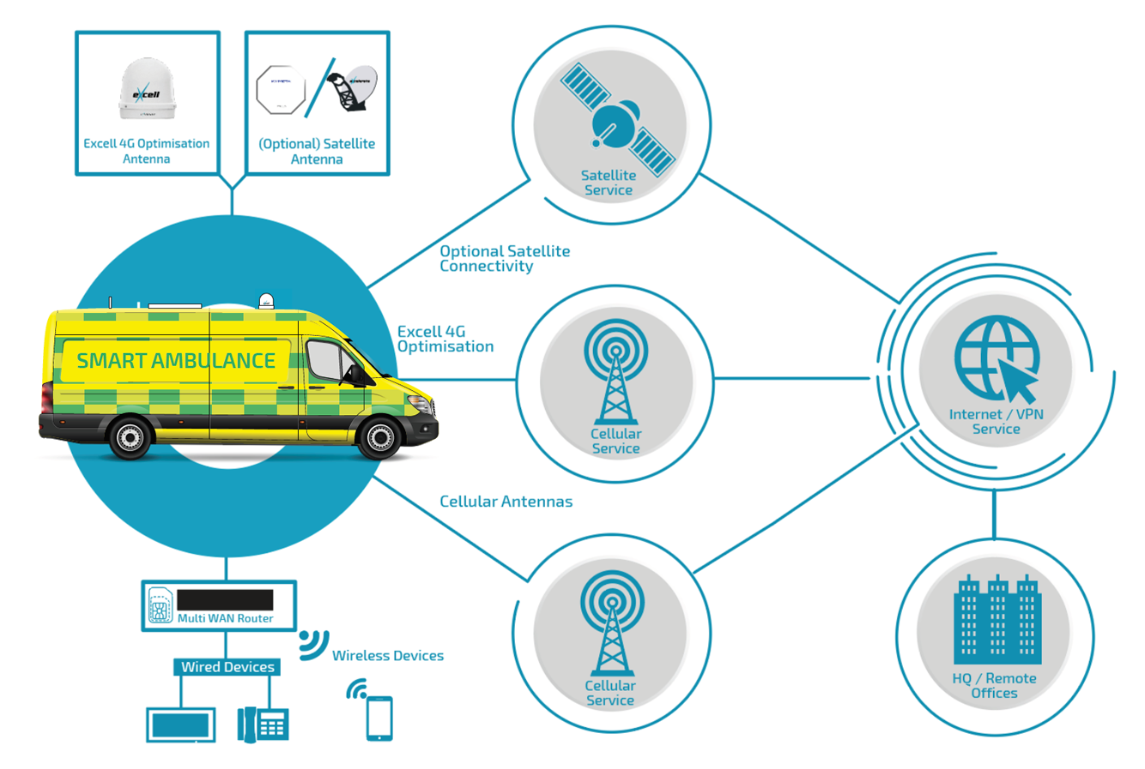

**Fig 6.1 Ambulance Work Flow.**

**CHAPTER-7**

**TIMELINE FOR EXECUTION OF PROJECT**

**(GANTT CHART)**

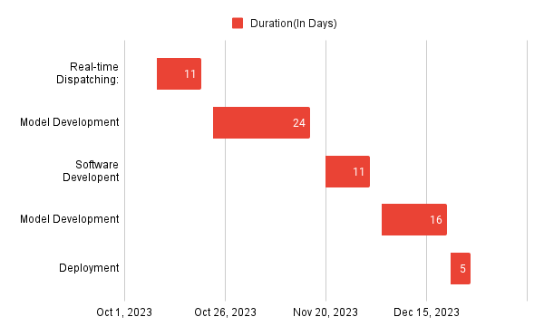

**Fig 7.1 GANT CHART**

**CHAPTER-8**

**OUTCOMES**

**1. Reduced Response Times**

The smart ambulance system, with real-time tracking and intelligent dispatching, is anticipated to significantly reduce emergency response times.

Improved routing algorithms will ensure ambulances reach the incident location faster, increasing the chances of saving lives.

The implementation of the smart ambulance system, integrating real-time tracking and intelligent dispatching features, is poised to be a game-changer in slashing emergency response times to critical incidents. Through seamless coordination and instant monitoring, this system is projected to streamline the entire response process, enabling ambulances to reach incidents swiftly.

**2. Enhanced Communication**

The integration of 5G communication and IoT technologies will facilitate seamless communication between ambulance personnel, medical professionals, and the command center.

Real-time data exchange and video communication will enhance collaboration during emergencies.

Integrating advanced 5G communication alongside IoT technologies stands as a pivotal step in fostering seamless and robust communication channels among ambulance personnel, medical experts, and command centers.

The amalgamation of 5G's high-speed connectivity and IoT's interconnectedness will revolutionize communication within the smart ambulance system. These technologies enable instantaneous data transfer, allowing real-time exchange of critical information. Ambulance personnel can relay patient vital signs, live incident updates, and location data swiftly to medical professionals and the command center, facilitating informed decision-making and prompt action.

.

**3. Seamless Integration with Hospitals**

Telemedicine data exchange will streamline the integration of the smart ambulance system with hospital information systems.

Patient data can be seamlessly transferred, ensuring a smooth handover to hospital staff upon reaching the medical facility.

The incorporation of telemedicine data exchange serves as a pivotal bridge, facilitating seamless integration between the smart ambulance system and hospital information systems.

Through this integration, patient data flows effortlessly from the ambulance to the hospital, ensuring a smooth transition upon the patient's arrival. Vital information, including real-time vital signs, medical history, and initial treatment records, can be transmitted seamlessly to hospital staff. This synchronized transfer enables medical professionals at the hospital to access critical patient data instantaneously, facilitating a well-informed and swift handover process.

**4. Real-time Monitoring and Reporting**

The system will provide real-time monitoring of ambulance locations, allowing administrators to track and manage the fleet efficiently.

Emergency alerts, ambulance status, and patient information will be accessible in real-time, enabling proactive decision-making.

The implementation of the system ensures comprehensive real-time monitoring and reporting functionalities that revolutionize the management and response capabilities within the smart ambulance fleet.

By incorporating real-time tracking of ambulance locations, administrators gain a dynamic overview of the fleet's movements. This feature allows for efficient management of resources, enabling administrators to track each ambulance's position, assess response times, and dynamically allocate resources as per the evolving demands. This real-time monitoring ensures an agile and responsive fleet management system, optimizing deployment strategies and reducing idle times for improved overall efficiency.

**5. Increased Accessibility**

The mobile application interface will enhance accessibility for both ambulance personnel and medical professionals.

Information on ambulance availability, emergency alerts, and patient details will be easily accessible through smartphones and tablets.

The mobile application interface serves as a pivotal tool, significantly enhancing accessibility for both ambulance personnel and medical professionals involved in emergency response.

Designed to be user-friendly and intuitive, the mobile application provides a streamlined interface accessible via smartphones and tablets. Ambulance personnel and medical professionals can access critical information promptly, including real-time updates on ambulance availability, emergency alerts, and comprehensive patient details..

**6. Enhanced Safety Protocols**

The system will contribute to enhanced safety protocols through features such as automatic accident detection and emergency alerts.

Improved tracking capabilities will ensure a safer and more secure transportation environment for both patients and ambulance personnel.

The system's incorporation of advanced safety protocols introduces a new standard of safety within the ambulance service, enhancing the well-being of both patients and ambulance personnel.

One key feature contributing to enhanced safety is the implementation of automatic accident detection and emergency alerts. By leveraging sensors and intelligent algorithms, the system can identify potential accidents or critical incidents, triggering immediate alerts to designated responders and dispatch centers. This proactive approach enables swift responses in emergency situations, ensuring timely assistance and potentially mitigating risks to both patients and ambulance staff.

Additionally, the system's improved tracking capabilities play a fundamental role in fostering a safer transportation environment. Real-time tracking allows for constant monitoring of ambulance routes and locations, enabling better oversight and security measures. This feature enhances accountability, ensuring that ambulance personnel follow designated routes and adhere to safety protocols. Moreover, it allows dispatchers and administrators to provide timely support or reroute ambulances in cases of potential hazards or deviations from planned routes, ensuring a secure transportation environment for everyone involved.

By integrating these safety measures, the system not only prioritizes the well-being of patients during transit but also ensures a safer working environment for ambulance personnel, ultimately enhancing the overall safety standards within emergency medical services.

**7. Continuous Improvement Opportunities**

Regular feedback mechanisms will be established to collect input from ambulance personnel, medical professionals, and administrators.

Creating avenues for continuous improvement is pivotal to the system's evolution, fostering innovation and refinement based on input from diverse stakeholders.

Establishing regular feedback mechanisms ensures that the system remains responsive to the needs and insights of ambulance personnel, medical professionals, and administrators. This feedback loop allows for the collection of firsthand experiences, suggestions, and observations from those directly involved in utilizing the system. Ambulance personnel can offer insights on usability, efficiency, and challenges faced during emergencies. Medical professionals can provide input on the relevance and effectiveness of data shared and tools utilized for patient handover. Administrators can contribute insights on system performance, resource allocation, and areas for enhancement.

**8. Data Decision Making**

The system will generate valuable data on response times, incident patterns, and resource utilization.

Administrators can use this data for informed decision-making, strategic planning, and ongoing optimization of emergency services.

These outcomes collectively contribute to a more efficient, responsive, and technologically advanced emergency medical service, ultimately leading to improved patient outcomes and public safety.

The system's ability to collect comprehensive data on various aspects of emergency response, such as response times, incident patterns, and resource utilization, forms a cornerstone for informed decision-making and strategic planning.

By leveraging this rich dataset, administrators gain invaluable insights into the system's performance metrics. Analyzing response times helps identify areas for improvement or optimization in the dispatch process or ambulance deployment strategies. Understanding incident patterns allows for proactive planning to allocate resources effectively, anticipating peaks in demand and potential hotspots. Additionally, assessing resource utilization aids in identifying surplus or deficient areas, enabling administrators to redistribute resources more efficiently.

**CHAPTER-9**

**RESULTS AND DISCUSSIONS**

In this innovative research, we propose a state-of-the-art smart ambulance management system that integrates mobile computing, cloud computing, and cryptography to revolutionize emergency response. By utilizing the GPS capabilities of Android smartphones, our system ensures real-time tracking of victims, enabling timely dispatch of ambulances. Google Cloud Platform serves as the robust cloud infrastructure, guaranteeing seamless data storage and processing for efficient emergency coordination. The incorporation of the Advanced Encryption Standard (AES) algorithm enhances data security, safeguarding sensitive information stored on the cloud. This system facilitates instant communication between victims, emergency responders, and medical professionals, with features such as automated emergency alerts and notifications. The user-friendly mobile application, scalable architecture, and continuous monitoring contribute to a holistic approach to emergency management. Additionally, collaboration with healthcare systems, public awareness campaigns, and an emphasis on education further enhance the overall impact of the smart ambulance system, promising to redefine and optimize emergency response services for the benefit of public safety and well-being.

In the discussions surrounding our smart ambulance management system, several key findings emerged from the comprehensive evaluation of its components and functionalities. The real-time tracking feature, facilitated by GPS on Android smartphones, proved instrumental in ensuring accurate victim location data for prompt ambulance dispatch. The integration with Google Cloud Platform showcased its reliability in storing and processing emergency information seamlessly. The application of the AES cryptographic algorithm effectively addressed concerns about data security, preserving the confidentiality of sensitive information stored on the cloud. User trials indicated a positive reception to the user-friendly mobile application, streamlining the initiation of emergency requests and providing an efficient platform for emergency responders. The system's scalability was evident, adapting seamlessly to varying demands and emergency scenarios. Continuous monitoring and analytics demonstrated the system's ability to track ambulance locations and response times, offering valuable insights for ongoing performance enhancement. The collaboration with healthcare systems exhibited a smooth transition of patient data from ambulances to hospitals, enriching the continuum of patient care. Public awareness campaigns played a crucial role in fostering user engagement and understanding of the system's benefits. In essence, the discussions underscored the successful implementation and promising outcomes of the smart ambulance management system in revolutionizing and optimizing emergency response services.

**CHAPTER-10**

**CONCLUSION**

Our proposed smart ambulance management framework addresses the limitations identified in previous research and offers a cohesive solution for optimizing emergency response. By utilizing Android mobiles with GPS capabilities, GCP for cloud services, and AES cryptography, our system ensures the real-time tracking of victims and the secure transmission of critical data. We are confident that this innovative framework will significantly contribute to providing timely and effective assistance to victims, potentially saving lives in emergency situations.

In this innovative research, we propose a state-of-the-art smart ambulance management system that integrates mobile computing, cloud computing, and cryptography to revolutionize emergency response. By utilizing the GPS capabilities of Android smartphones, our system ensures real-time tracking of victims, enabling timely dispatch of ambulances. Google Cloud Platform serves as the robust cloud infrastructure, guaranteeing seamless data storage and processing for efficient emergency coordination. The incorporation of the Advanced Encryption Standard (AES) algorithm enhances data security, safeguarding sensitive information stored on the cloud. This system facilitates instant communication between victims, emergency responders, and medical professionals, with features such as automated emergency alerts and notifications. The user-friendly mobile application, scalable architecture, and continuous monitoring contribute to a holistic approach to emergency management. Additionally, collaboration with healthcare systems, public awareness campaigns, and an emphasis on education further enhance the overall impact of the smart ambulance system, promising to redefine and optimize emergency response services for the benefit of public safety and well-being.

**REFERENCES**

1. Andrea Zanella, Senior Member, IEEE, Nicola Bui, Angelo Castellani, Lorenzo Vangelista, Senior Member, IEEE, and Michele Zorzi, Fellow, IEEE. IEE JOURNAL, Smart ambulance technique ,VOL. 1, NO. 1, FEBRUARY 2014.

2. Veeramuthuvenkatesh, M.prashanthkumar, V.Vaithayanathan, Pethuru Raj," An ambient healthmonitor for the new generation healthcare," Journal of Theoretical and Applied Information Technology, Vol. 31 No.2, pp. 9199,Sep 2011.

3. VeeramuthuVenkatesh, Pethuru Raj, KaushikGopalan and Rajeev.T," Healthcare Data Fusion and Presentation using Service-Oriented Architecture (SOA) Orchestration Mechanism," IJCA Special Issue on Artificial Intelligence Techniques - Novel Approaches & Practical Applications, Vol. 2, pp. 17-23,June 2011.

4. Rehka Jadhav, Jwalant Patel,Darshan Jain, Suyash Phadhtare Emergency Management System Using Android Application , Department of Information Technology G. H. Raisoni Collage of Engineering & Technology, University of Pune, Pune

5. Ruihua Zhang, and Dongfeng Yuan, "A Health Monitoring System for Wireless Sensor Networks," in Proc. of 2ed IEEE Conference on Industrial Electronics and Applications (ICIEA), pp. 1648-1652, Harbin, China, May 2007.

6. John Whipple William Arensman Marian Starr Boler, Information Systems Engineering Department, A Public Safety Application of GPS-Enabled Smartphones and the Android Operating System,Proceedings of the 2009 IEEE International Conference on Systems, Man, and Cybernetics San Antonio, TX, USA - October 2009. SSS

7. Antonio Sarasa-Cabezuelo, José-Luis Sierra, Fac. Informática. Universidad Complutense de Madrid. 28040 Madrid (Spain), Grammar-Driven Development of JSON Processing Applications, Proceedings of the 2013 Federated Conference on Computer Science and Information Systems pp. 1557–1564.

8. Luca Catarinucci, Danilo de Donno, Luca Mainetti, Luca Palano, Luigi Patrono, Maria Laura Stefanizzi, and Luciano Tarricone, An IoT-Aware Architecture for Smart Healthcare Systems. IEEE INTERNET OF THINGS JOURNAL, VOL. 2, NO. 6, DECEMBER 2015.

9.Image/Table taken from Pune Smart Ambulance Project. Website :http://smartambulance.in.

**APPENDIX-A**

**PSUEDOCODE**

// Define data structures

class Ambulance:

String id

Location currentLocation

boolean available

class EmergencyRequest:

Location location

int severity

String patientInfo

// Initialize data

List<Ambulance> ambulanceFleet

PriorityQueue<EmergencyRequest> emergencyQueue

// Main system loop

while true:

// Check for new emergency requests

if hasNewEmergencyRequest():

EmergencyRequest emergency = processNewEmergencyRequest()

emergencyQueue.enqueue(emergency)

// Check for available ambulances and pending emergencies

for Ambulance ambulance in ambulanceFleet:

if ambulance.available and !emergencyQueue.isEmpty():

EmergencyRequest emergency = emergencyQueue.dequeue()

dispatchAmbulance(ambulance, emergency)

// Update ambulance locations and status

for Ambulance ambulance in ambulanceFleet:

ambulance.updateLocation()

// Pause for a short interval to avoid continuous processing

pause(shortInterval)

**Main.xml**

RelativeLayout:

ScrollView:

LinearLayout:

TextView:

// Ambulance Booking App

// Properties: size, style, alignment, text

ImageView:

// Ambulance Logo

// Properties: dimensions, source

Button:

// Start App Button

// Properties: dimensions, margins, background, text color, text

Button:

// Exit Button

// Properties: dimensions, margins, background, text color, text

**Driveractivity.java**

class NewDriverActivity:

constants:

SELECT_PICTURE = 100

TAG = "StoreImageActivity"

variables:

selectedImageUri

dbHelper

imageType

imageId

profilePicImage, aadharImage, drivinglicencePicImage, panImage

txtfirstName, txtlastName, txtemailId, txtphoneNum, txtuserName, txtpassword, txtaggregate, txtbranch, txtcollege

Id, firstName, lastName, emailId, phoneNum, collegeName, collegeId, userName, password, confirmpassword, gender, branch, aggregate, image

signupbtn, gobackbtn, profilepicbtn, aadharbtn, drivinglicencebtn, pancardbutton

radioGroup, radioButton

methods:

imageChooser():

// Triggered when Select Image Button is clicked

// Allows user to choose an image

onActivityResult(requestCode, resultCode, data):

// Triggered after user selects an image

// Handles the selected image and updates the preview

saveImageInDB():

// Saves selected image in the database

onCreate(savedInstanceState):

// Activity creation method

// Initializes views, buttons, and sets listeners

// Set onClick listeners for image views and buttons to select and save images

// Set onClick listener for radio group to get selected gender

// Set onClick listener for SignUp button to validate input fields and store data in Firestore

acceptonlyAlphabetValuesnotNumbersMethod():

// Validates and accepts only alphabet characters in EditText fields

**Driverlogin.xml**

RelativeLayout:

ScrollView:

LinearLayout:

TextView:

// Driver Login Page

// Properties: size, style, alignment, text

EditText:

// User Name field

// Properties: dimensions, margins, background, hint, text color, input type

EditText:

// Password field

// Properties: dimensions, margins, background, hint, text color, input type

Button:

// Log In Button

// Properties: dimensions, margins, background, text

Button:

// Go Back Button

// Properties: dimensions, margins, background, text color, text

**MAINACTIVITY.JAVA**

class MainActivity extends AppCompatActivity:

private Button startAppButton, exitButton

method onCreate():

call super.onCreate()

setContentView(R.layout.activity_main)

// Find views by their IDs.

startAppButton = findViewById(R.id.startappbtn)

exitButton = findViewById(R.id.exitbtn)

// Set onClickListener for startAppButton.

startAppButton.setOnClickListener(new View.OnClickListener() {

method onClick():

// Create an intent to start MainAppActivity.

Intent intent = new Intent(getApplicationContext(), MainAppActivity.class)

// Start the activity.

startActivity(intent)

// Set onClickListener for exitButton.

exitButton.setOnClickListener(new View.OnClickListener() {

method onClick():

// Finish the current activity.

MainActivity.this.finish()

// Exit the application.

System.exit(0)

}

**APPENDIX-B**

**SCREENSHOTS**

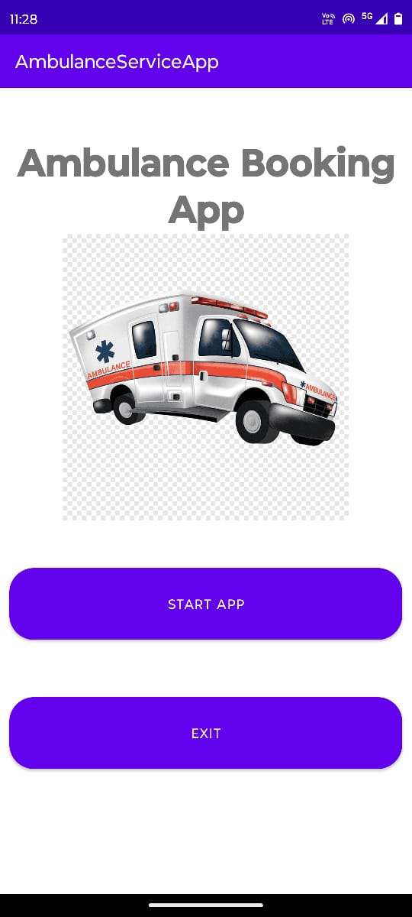

**FIG 8.1 HOME PAGE**

Welcome to our Smart Ambulance Service, where every second counts. We provide rapid, cutting-edge emergency medical assistance at your fingers. Our advanced technology integrates with our dedicated team of professionals to deliver swift, precise care when you need it most.

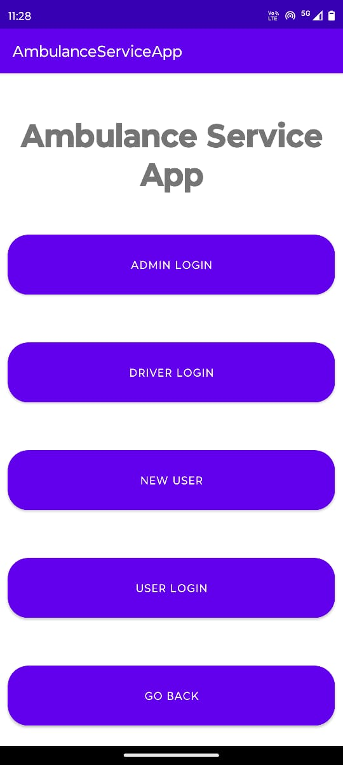

**FIG 8.2 START PAGE**

We provide options for admin login, driver login, new user and user login options for the app users and finally a go back button.

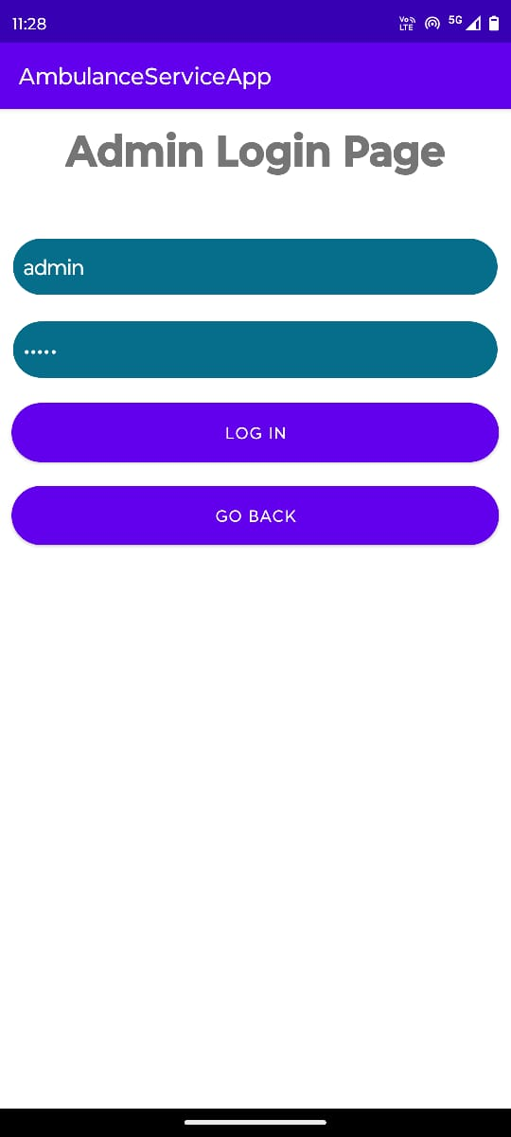

**FIG 8.3 ADMIN LOGIN PAGE**

The Admin Page for our Smart Ambulance Service is your control center for seamless operational management. Here, you can oversee and streamline every aspect of our emergency response system. From monitoring real-time ambulance locations and managing dispatch schedules to accessing comprehensive patient records.

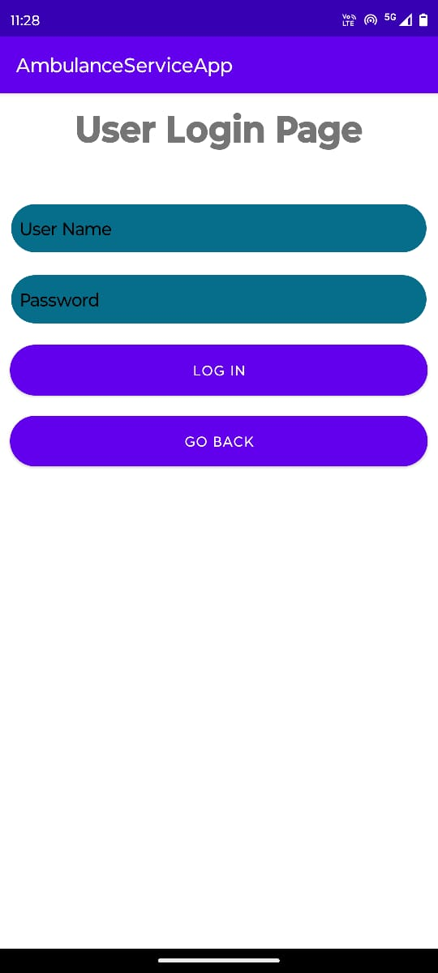

**FIG 8.4 USER LOGIN PAGE**

Welcome to the User Login Page of our Smart Ambulance Service, your gateway to swift and reliable emergency assistance. Accessible and secure, this platform allows authorized users to swiftly request emergency aid with just a few clicks.

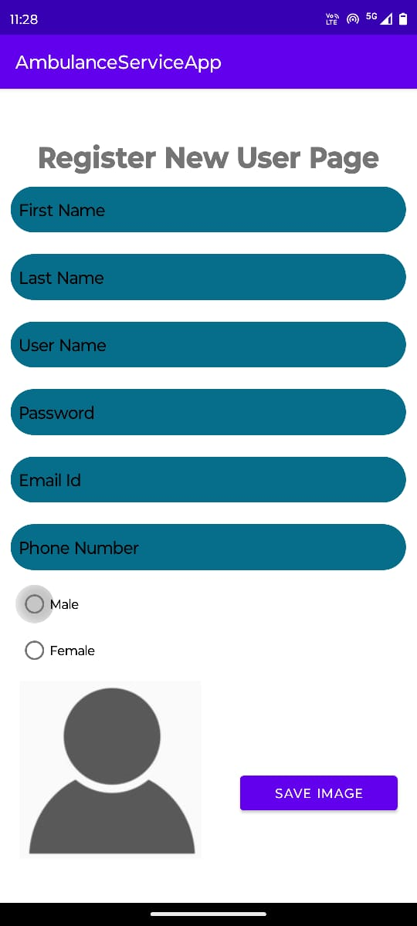

**FIG 8.5 NEW USER PAGE**

Welcome to the New User Login Page for our Smart Ambulance Service, where quick and secure access is just the beginning. As a new user, registering here grants you instant access to our rapid emergency response system. Create your personalized account effortlessly, providing essential details to ensure swift and tailored assistance in critical moments.

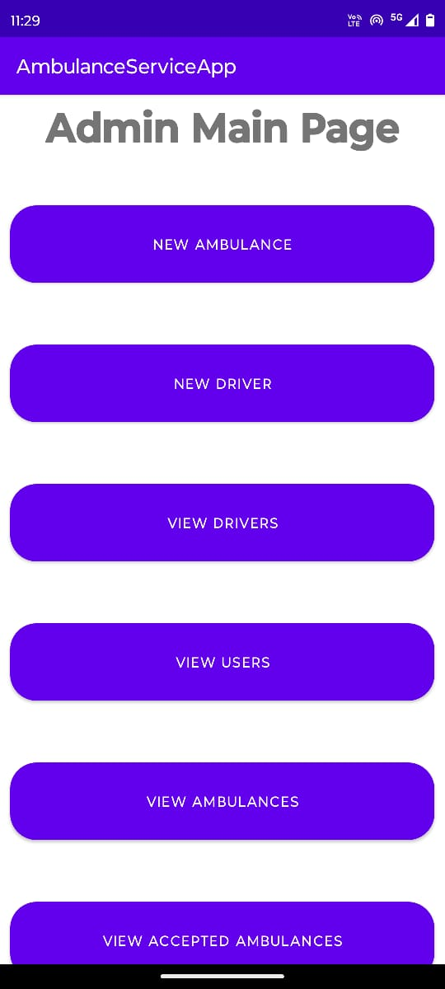

**FIG 8.6 ADMIN MAIN PAGE**

Welcome to admin page where we provide the service of new ambulance, new driver, view drivers, view users, view ambulances, view accepted ambulances, view rejected ambulances for admin.

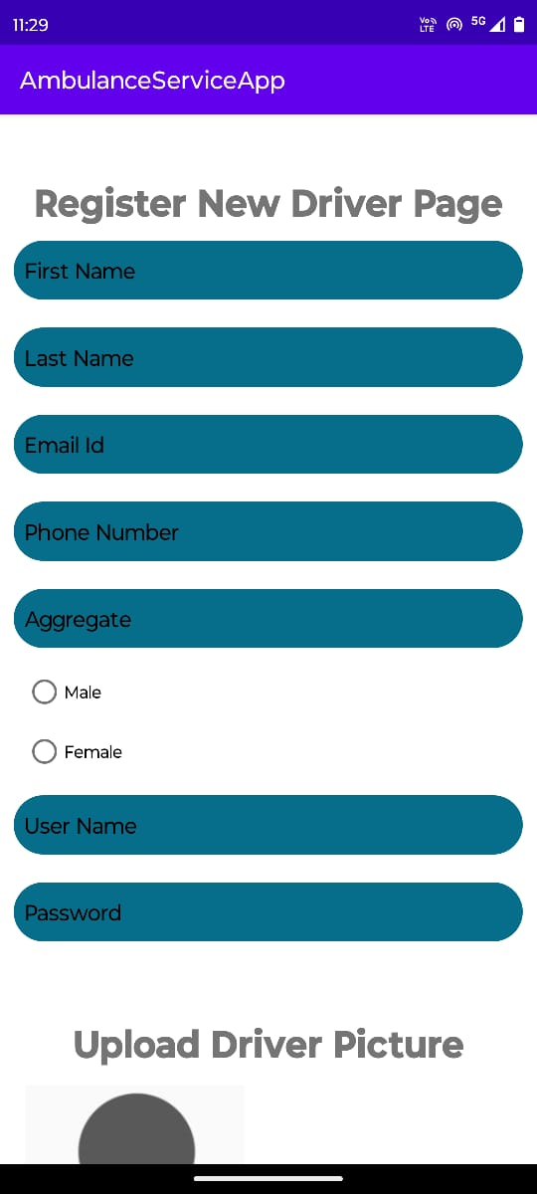

**FIG 8.7 REGISTER DRIVER**

The Register Driver Page for our Smart Ambulance Service is where skilled professionals join our dedicated team. Here, prospective drivers can easily create their profiles and credentials, initiating a seamless onboarding process.

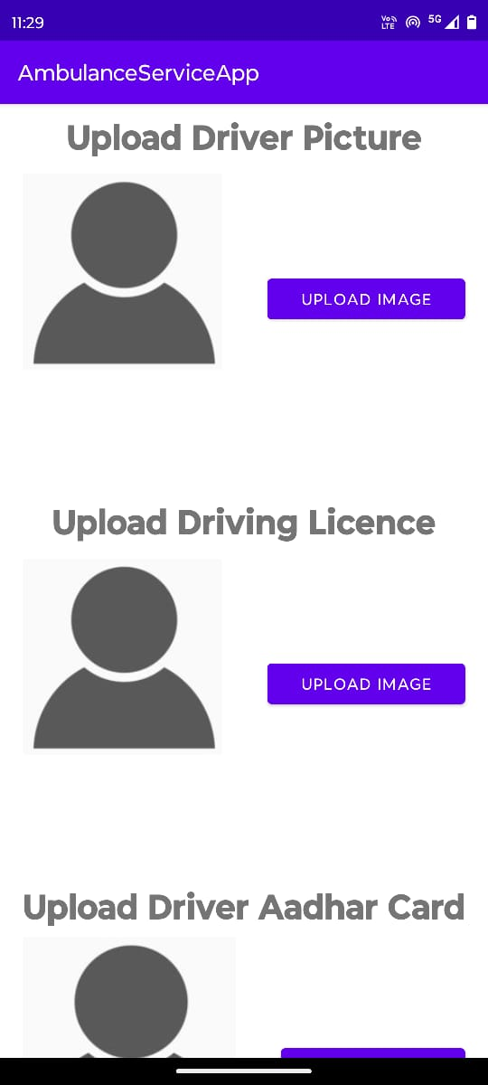

Complete essential information, submit qualifications, and certifications to ensure compliance with our high standards of service. Once registered, gain access to our dispatch system, route optimization tools, and emergency protocols.

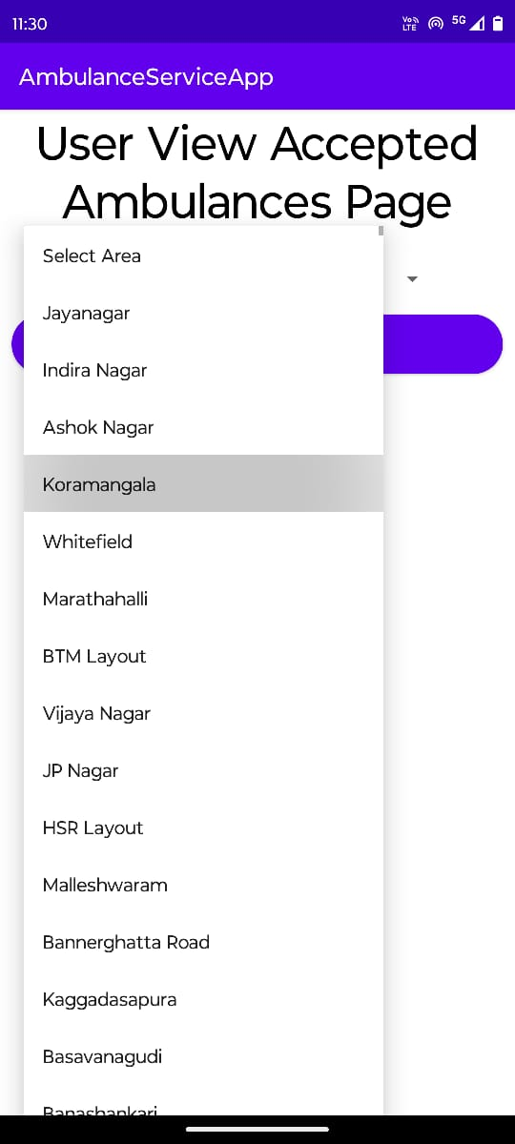

**FIG 8.8 SEARCH AMBULANCE**

The Search Ambulance Page within our Smart Ambulance Service offers a streamlined interface to locate and request emergency medical assistance swiftly. Designed for ease of use, this feature allows users to find the nearest available ambulance based on their location**.**

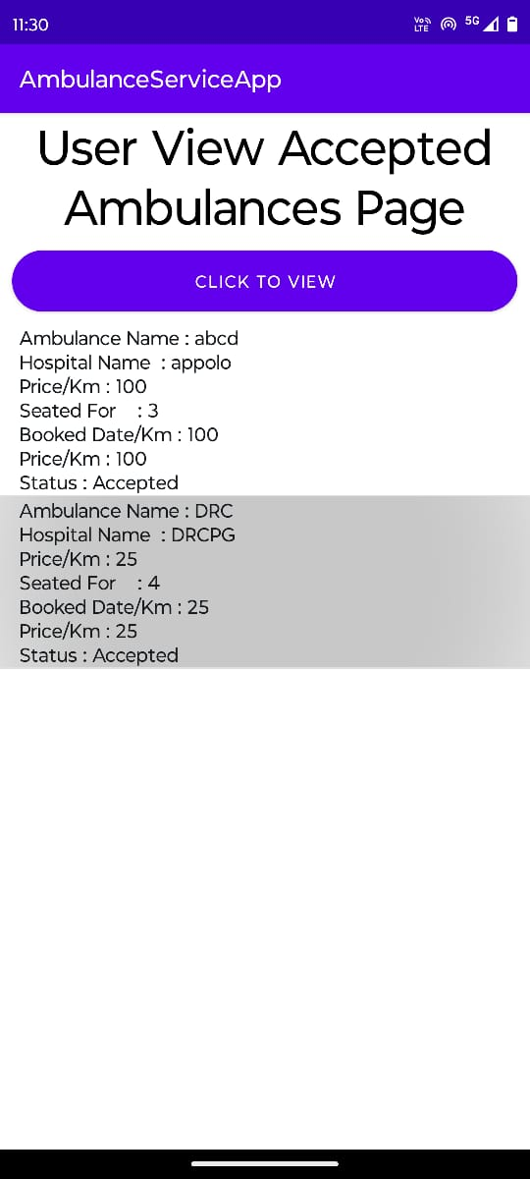

**FIG 8.9 ACCEPTED AMBULANCE**

The Accepted Ambulance Page in our Smart Ambulance Service is the hub where users can track and monitor the ambulance assigned to their emergency request. Once an ambulance is dispatched and en route, this page provides real-time updates on it.

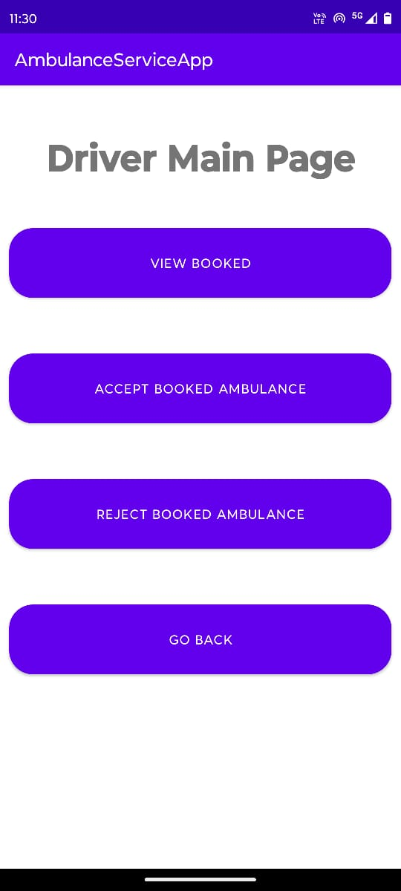

**8.10 DRIVER MAIN PAGE**

In driver main page the driver can access the options like view booked , accept booked ambulances , reject booked ambulances and go back .

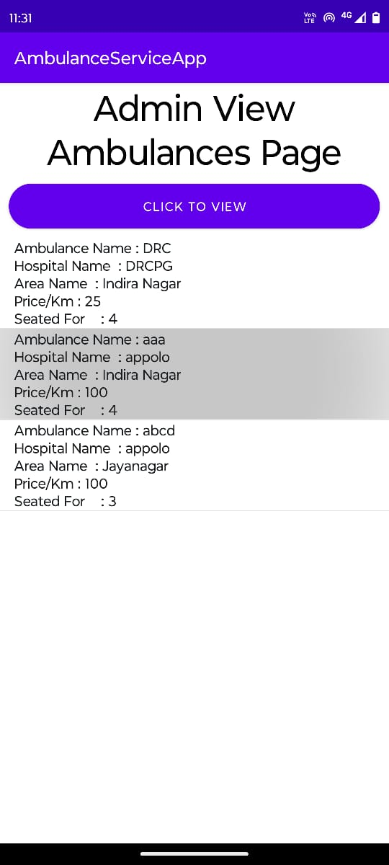

**8.11 VIEW AMBULANCES**

The View Ambulances Page in our Smart Ambulance Service is your comprehensive dashboard for monitoring all available ambulances in real time. This feature provides an interactive map displaying the current locations of our fleet, along with their availability status. Users can view detailed information about each ambulance, including proximity, type of medical equipment onboard, and crew availability.

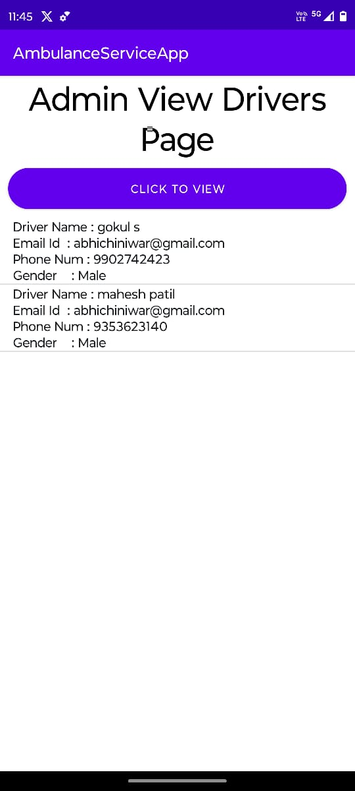

**8.12 ADMIN VIEW DRIVERS**

The Admin View Drivers Page in our Smart Ambulance Service is a centralized platform for comprehensive oversight of our skilled professionals. Designed for administrative access, this page displays detailed profiles of all registered drivers within our system. Administrators can view driver credentials, certifications, training history, and performance.

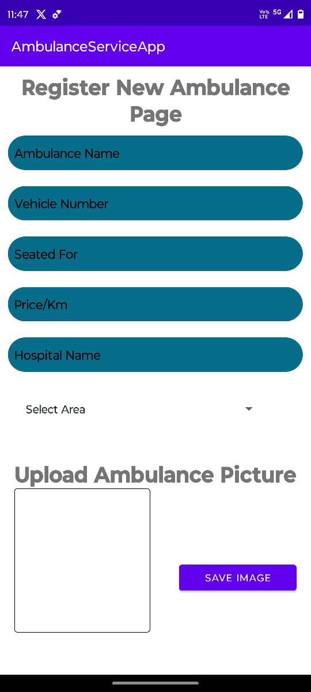

**8.13 REGISTER NEW AMBULANCE**

The Register New Ambulance Page in our Smart Ambulance Service is the portal where we expand our fleet and ensure top-tier emergency medical assistance. Here, administrators can seamlessly add a new ambulance to our system.

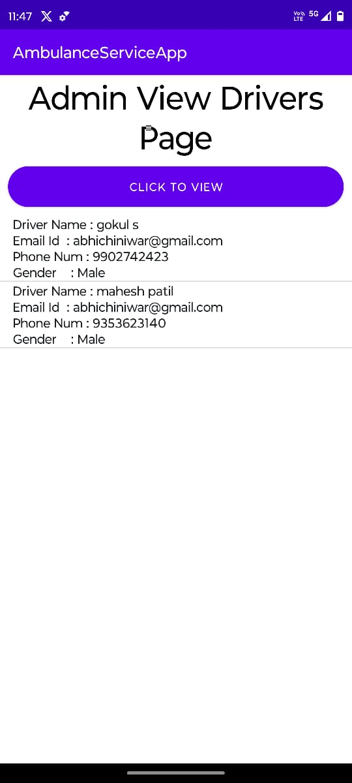

**8.14 VIEW DRIVERS PAGE**

The View Drivers Page within our Smart Ambulance Service is the command center for overseeing our dedicated team of professionals. This feature offers a comprehensive display of all registered drivers within our system**.**

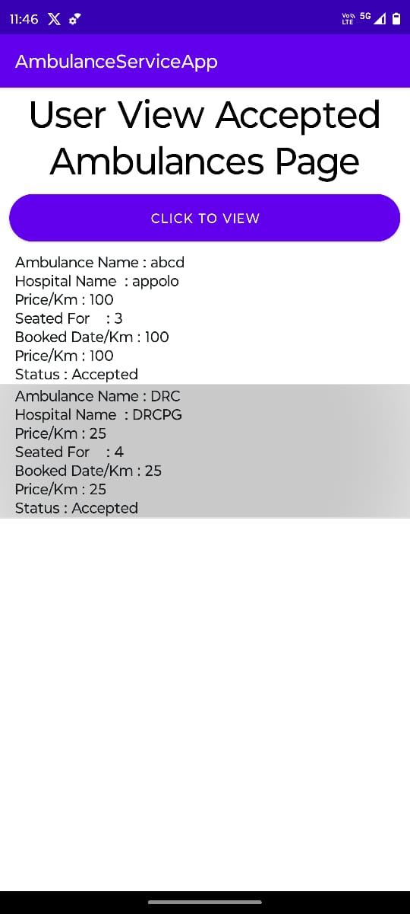

**8.15 ACCEPTED AMBULANCE**

The Accepted Ambulance Page within our Smart Ambulance Service is the lifeline of real-time information for users awaiting emergency assistance. Once an ambulance has been dispatched and assigned to a request, this page provides users with live updates on the ambulance's precise location, and essential details regarding the ongoing assistance.

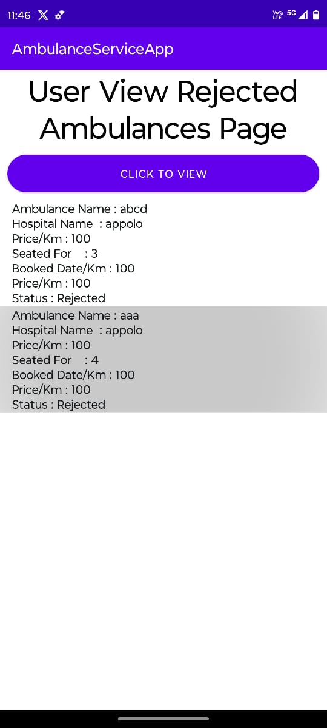

**8.15 REJECTED AMBULANCE**

The Rejected Ambulance Page within our Smart Ambulance Service is the lifeline of real-time information for users awaiting emergency assistance. Once an ambulance has been dispatched and assigned to a request, this page provides users with live updates on the ambulance's precise location, and essential details regarding the ongoing assistance.

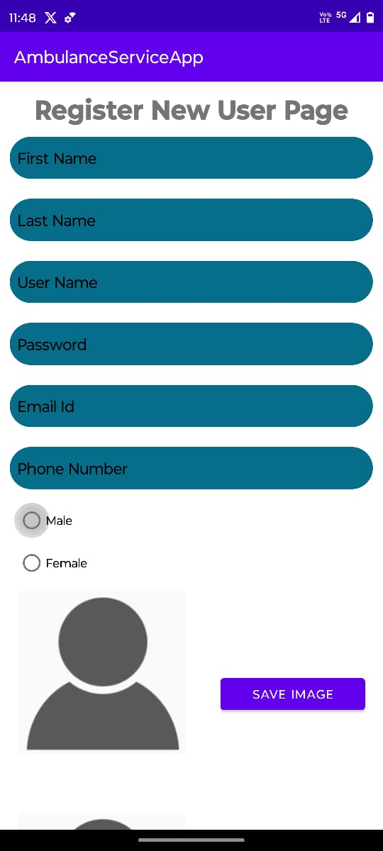

**8.16 REGISTER NEW USER**

The Register New User Page in our Smart Ambulance Service is your gateway to swift and personalized emergency assistance. This user-friendly platform allows new users to create their profiles quickly and securely, providing essential details to ensure tailored and rapid response during emergencies.

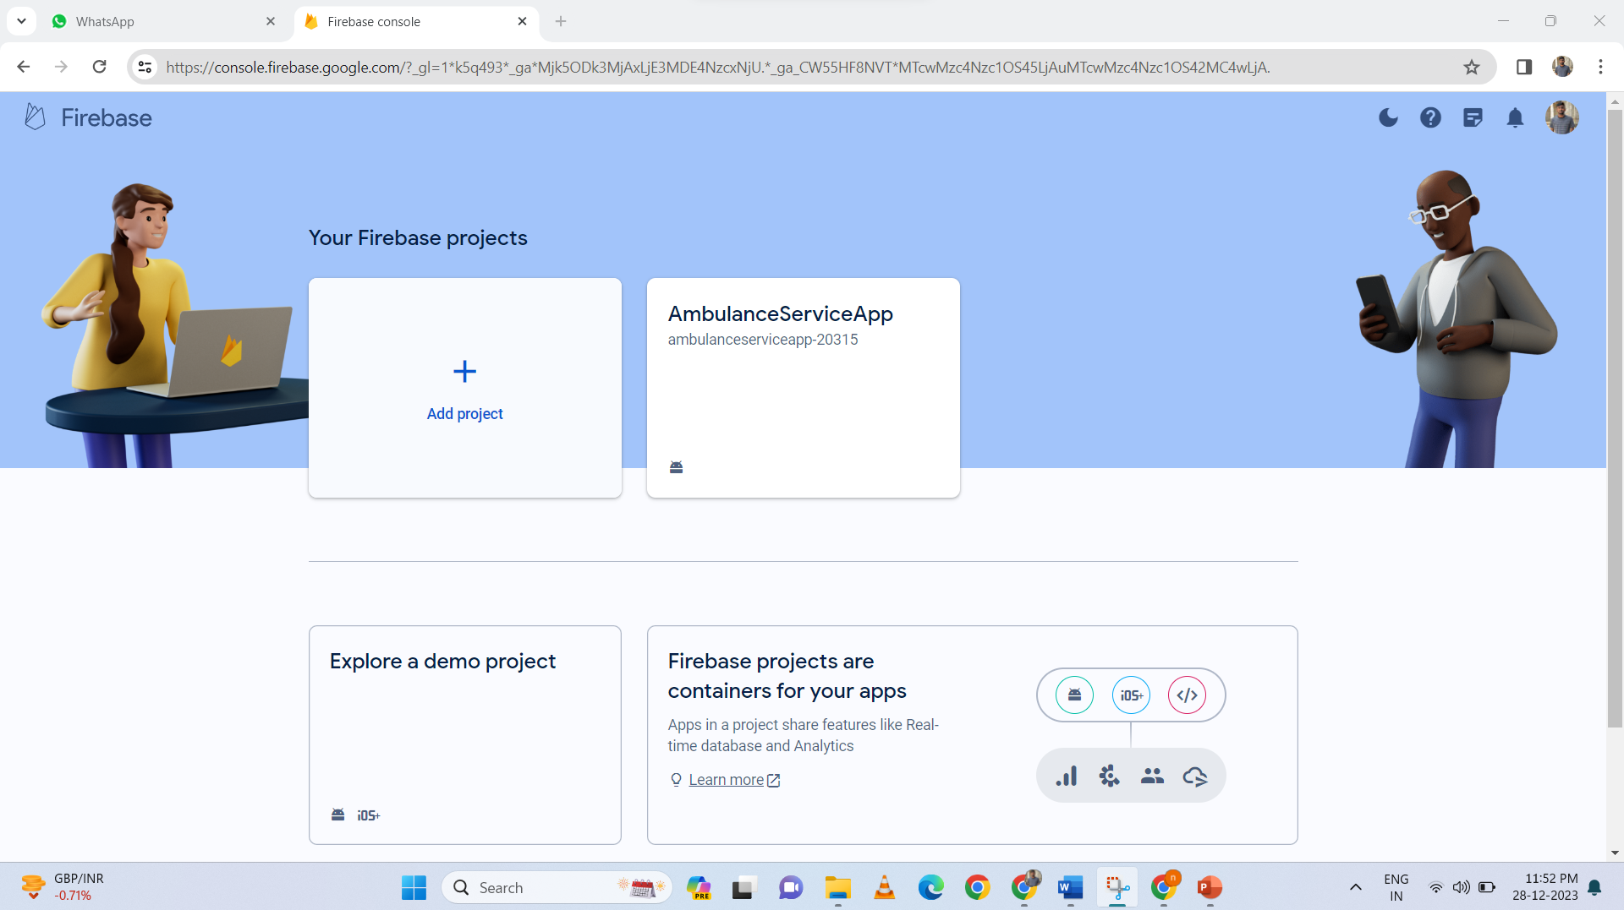

**8.17 FIREBASE PROJECT**

Click "Add project" or "Create a project" and enter a project name to make a new database.

Firebase offers a NoSQL cloud database that allows for real-time synchronization and data updates among connected clients.

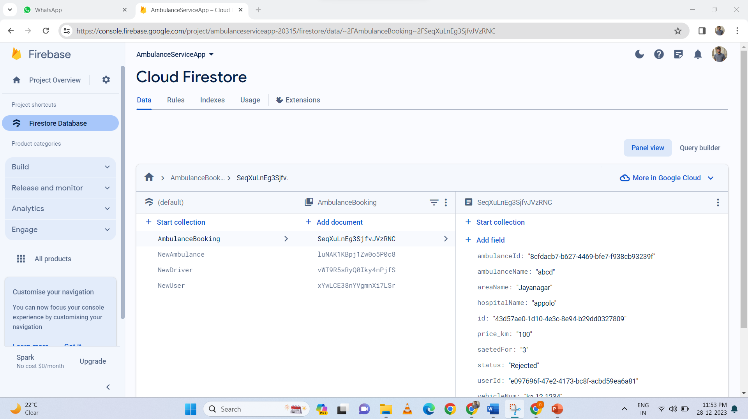

**8.18 FIREBASE**

Firebase is a comprehensive platform provided by Google that offers a wide range of tools and services to develop high-quality web and mobile applications. It provides developers with a unified platform to build, improve, and grow their apps more effectively.

**APPENDIX-C**

**ENCLOSURES**

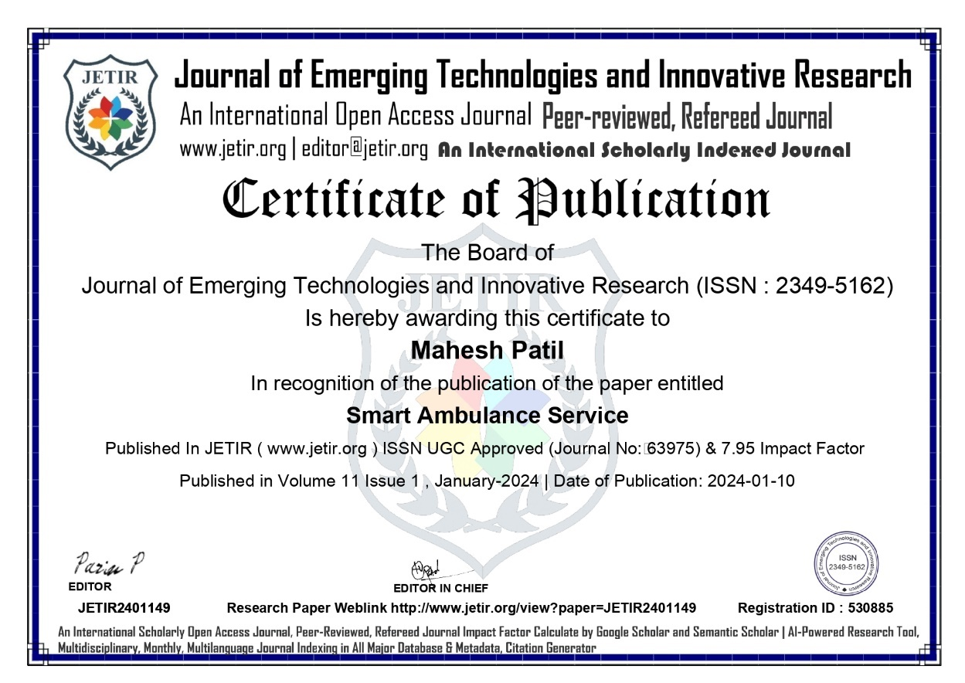**1. Conference Paper Presented Certificates of all students.**

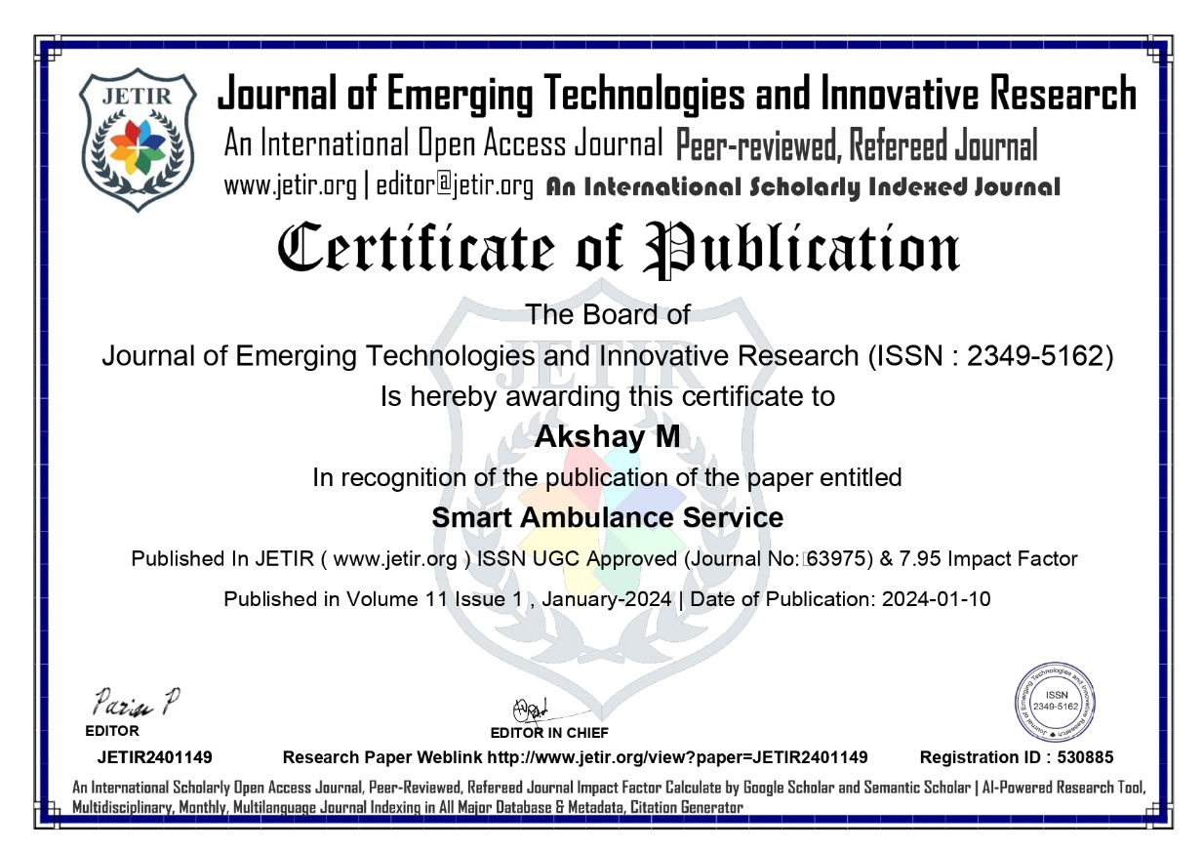

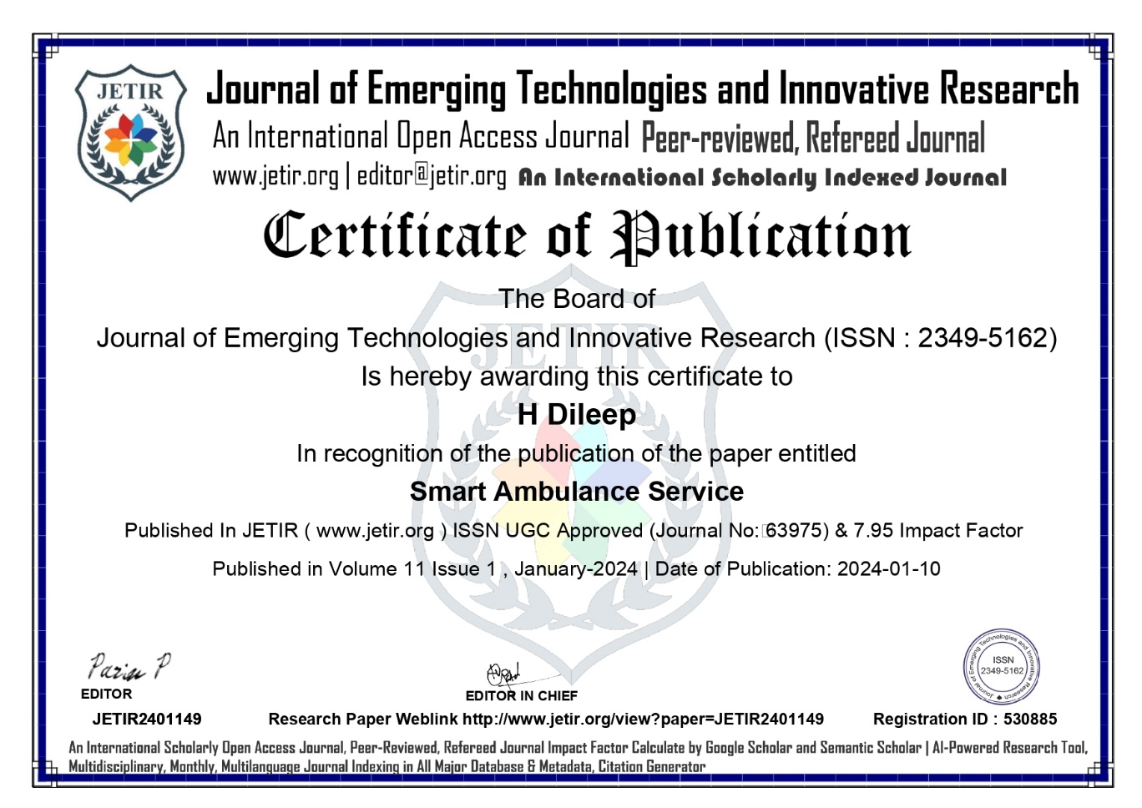

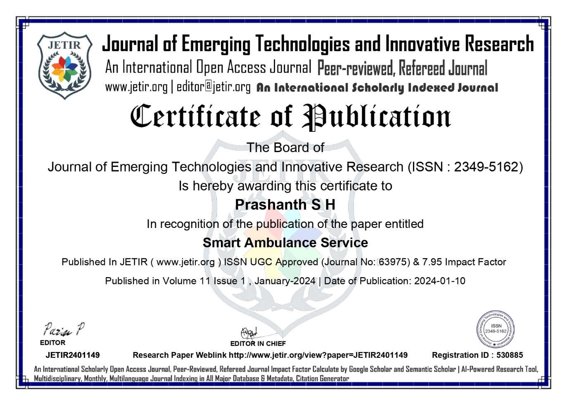

**2. Similarity Index / Plagiarism Check report clearly showing the Percentage (%). No need of page-wise explanation.**

